**FOR IMMEDIATE RELEASE Contact:** Jotham Austin, II PhD, Author

**Phone:** 303-875-7449

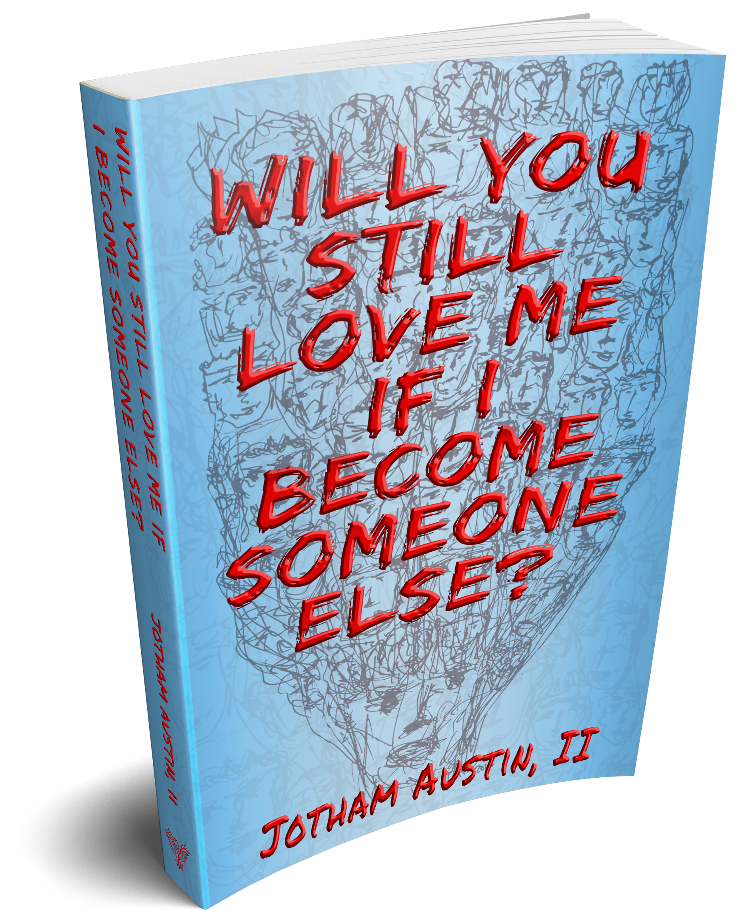 **Email:** [joe@jothamaustin.com](mailto:joe@jothamaustin.com)

**Social:** <https://linktr.ee/Jothamaustin>

**Debut Psychological Techno-Thriller by UChicago Research Assistant Professor**

Chicago, IL - RhetAskew Publishing is proud to debut a new novel “Will You Still Love Me If I Become Someone Else?” by University Chicago scientist Dr. Jotham Austin on February 23, 2021. Available in digital and paperback at: books2read.com/jotham

**Book Summary**

**What if you had the memories of 110 people stuffed into your brain? How would you know who you really are?**

The passengers of flight 2164 all lose their memories except Brian; he not only maintains his own memories, but gains everyone else’s that was on the plane.

As Brian begins remembering the other passenger’s lives, and soon finds himself unable to separate his memories from theirs. Intense flashbacks, disjointed personalities and often violent outbursts puts a strain on Brian's relationship with his fiancée, Brenda.

They have to trust a neuroscientist, Marci, that may have experimental technology to restore Brian’s memories and the life Brenda and Brian once had. They will have to trust the neuroscientist, Marci, whose experimental technology could restore Brian’s memories, and the life Brenda and Brian once had. As Brenda and Marci race against time to untangle Brian’s memories from those of the other passengers, they discover secrets Brian hid about his past.

Brenda will have to decide if some memories are best forgotten, and can she still love who Brian really is?

**What Others Are Saying**

“What happens when ABC's series LOST and NBC's series MANIFEST have a child? If your answer's not **Will You Still Love Me, If I Become Someone Else?,** it will be after you read Jotham Austin II's debut novel. The book is well constructed and filled with sights, sounds, and scents that enhance the imagination and keep you reading...” —C.R.Downing, Sci-fi author of the award winning series Traveler’s Hot L

“Buckle up for a fast paced stream of consciousness story through many memories and the search for who’s who, all sensuously told with much provocative dialogue and abundant visual cues to spark your imagination. If you like your science fiction with plenty of in depth relationships and you want something that you won’t want to stop reading, this is it. Jotham takes you through the “what if" of memory manipulation meanwhile including a mystery and a twist at the end. Will you see it coming?”—Wendy Wilder, Author, Editor, Reader

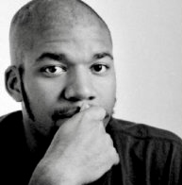

**About the Author**

Jotham Austin, II lives in Chicagoland with his wife and two sons. He has his PhD in Botany, and can be found taking electron micrographs of cells at The University of Chicago. When Jotham is not in the lab or writing, he splits his free time between gardening, woodworking, and home-brewing.

###